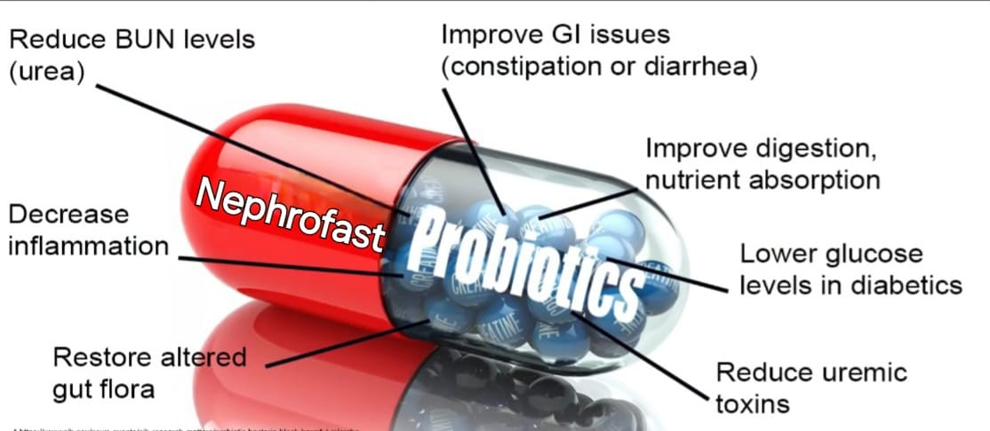**Several studies have been made on probiotics for kidney patients and it’s already a good sign, it means scientists think this works and they already able to prove that probiotics supplements are beneficial in the reduction of urea in patients with non-dialysis chronic kidney disease. Studies showing that probiotics can lower your urea nitrogen or bun in your lab values.**

s

**Urea Nitrogen is a normal wastes products in your blood that comes from the breakdown of protein from food you eat and from your blood metabolism. It is normally removed from your blood by your kidney but when kidney function slows down the BUN levels rises. Studies showing that probiotics were found have to lower levels of urea meaning that your body was able to process uremic toxin better, reducing the workload on the kidney.**

**Probiotics Will help you if you have an altered gut flora, now unfortunately people with CKD have altered gut flora almost constantly. Kidney disease can along mess up your gut flora, people with CKD have altered gut flora. This is not good for your kidney health and it is also cause constipation or diarrhea.**

**In kidney disease consider that it will decrease your body’s ability to absorb nutrients and your kidney need those nutrients. And also probiotics can helps lowering blood sugar. If you are diabetic’s patient you must add those probiotic for that reason.**

**Inflammation this is important, having less Inflammation less wastes products in your body and less glucose in diabetics are all great way to helps your kidney health.**

**Dosage Guideline: 1 Capsul twice a day with meal for 3 months**

Ref:

* https://www.ncbi.nlm.nih.gov/pmc/articles/PMC5031164/
* <https://www.nih.gov/news-events/nih-research-matters/probiotic-bacteria-block-harmful-microbe>
* https://www.ncbi.nlm.nih.gov/pmc/articles/PMC5302305/

<https://www.ncbi.nlm.nih.gov/pmc/articles/PMC4838534/>

**Life Care Pharma** introduces

***Nephrofast***

***Capsules***

Pre & Pro Biotic Blend- 45 Billion CFU

**Nephrofast Advance combination of Pre & Pro-Biotic** **supplements that are most beneficial for chronic kidney disease patients.**



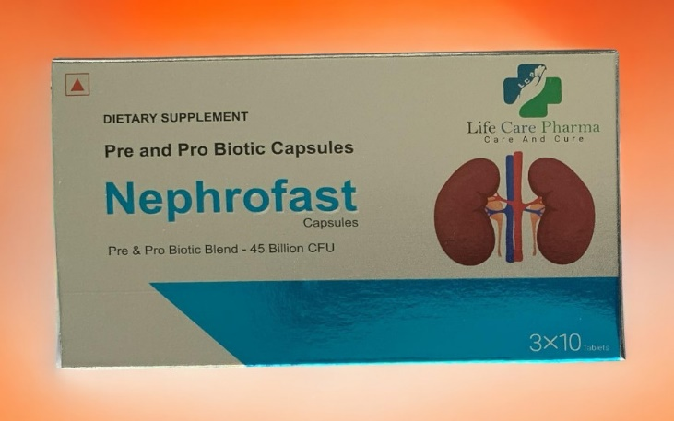**Uremic Toxins is a normal wastes products in your blood that comes from the breakdown of protein from food you eat and from your blood metabolism. It is normally removed from your blood by your kidney but when kidney function slows down the harmful Toxins, Nitrogenous wastes, Uremic toxins, creatinine levels are rises .Some specified Bacteria like Lactobacillus Acidophilus, Bifidobacterium Longum, Streptococcus Thermophiles**  **and home remedies decrease that levels.**

**Advance combination of Pre & Pro-Biotic Only for Kidney patients**

***Nephrofast Effective For***

* **Remove Harmful Toxins**
* **Remove Nitrogenous wastes**
* **Remove Uremic toxins**
* **Chronic kidney disease (CKD)**
* **Improving Gut Dysbiosis**
* **Slow Down Disease Progression**
* **Healthy Digestive System**
* **Decreases creatinine levels.**